# Entity Class

## User entity

### Class Diagram

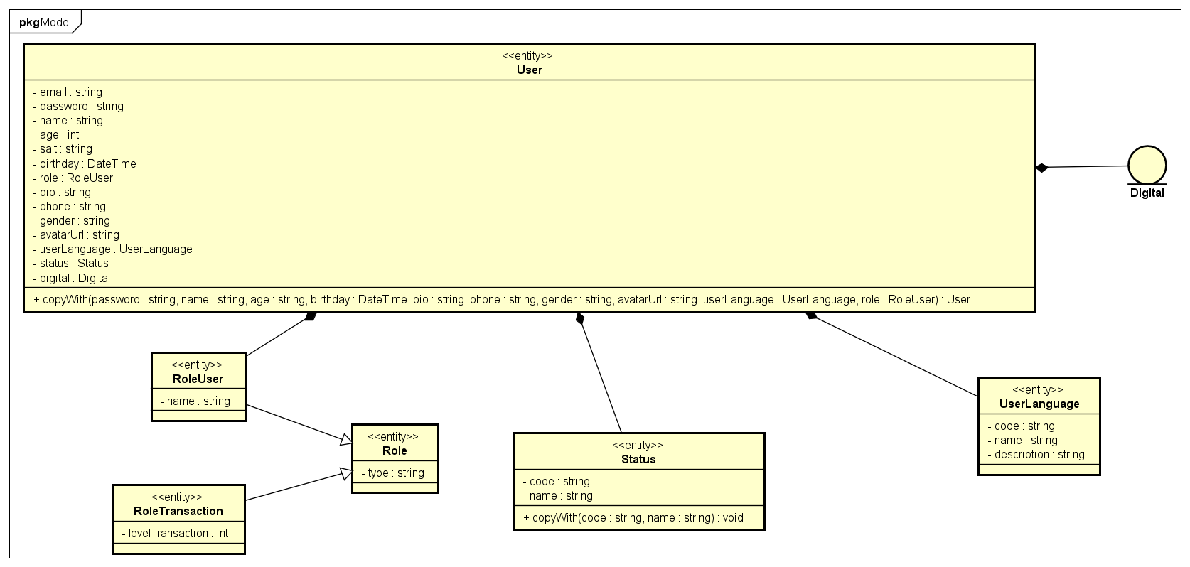

### Attribute

|  |  |  |  |
| --- | --- | --- | --- |
| # | Tên | Kiểu trả về | Description |
| 1 | email | string | email of user |
| 2 | password | string | password account of user |
| 3 | name | string | user’s name |
| 4 | age | int | age |
| 5 | salt | string | for security |
| 6 | birthday | DateTime | birthday |
| 7 | role | RoleUser | role of user |
| 8 | bio | string | introduction of user |
| 9 | phone | string | number phone |
| 10 | gender | string | male/female of things |
| 11 | avatarUrl | string | path to avatar of user |
| 12 | userLanguage | UserLanguage | the language that user uses |
| 13 | status | string | ONLINE/OFFLINE  BLOCKED. |

### Operation

|  |  |  |  |
| --- | --- | --- | --- |
| *#* | *Tên* | *Kiểu dữ liệu trả về* | *Mô tả (Mục đích)* |
| 1 | copyWith | User | create a copy user when updating information of user |

### Parameter

* Password: new password
* Name: new name
* Age: new age
* Birthday: new birthday
* Role: new role
* Bio: new bio
* Phone: new phone
* Gender: new gender
* avatarUrl: new avatarUrl
* userLanguage: new user language
* status: new status

### Exception

* No

### Method

* No

### State

* No

## Plan entity

### Class Diagram

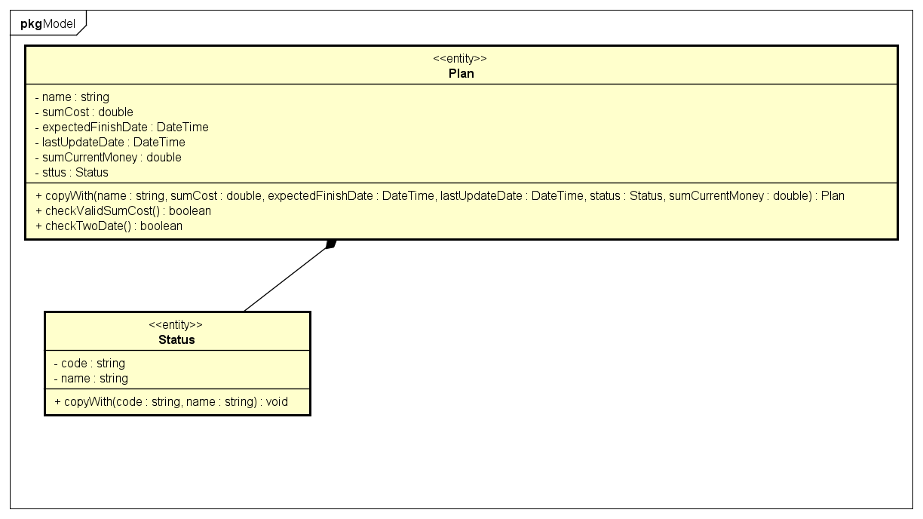

### Attribute

|  |  |  |  |
| --- | --- | --- | --- |
| # | Tên | Kiểu trả về | Description |
| 1 | name | string | user’s name |
| 2 | sumCost | double | Sum cost for plan |
| 3 | expectedFinishDate | DateTime | The date of completion of the plan |
| 4 | lastUpdateDate | DateTime | The nearest date that plan was updated |
| 5 | sumCurrentMoney | double | The sum current money for plan |
| 6 | status | string | FINISH/UNFINISH |

### Operation

|  |  |  |  |
| --- | --- | --- | --- |
| *#* | *Tên* | *Kiểu dữ liệu trả về* | *Mô tả (Mục đích)* |
| 1 | copyWith | Plan | create a copy plan when updating information of user |
| 2 | checkValidSumCost | boolean | The sum cost must be smaller than account balance |
| 3 | checkTwoDate | boolean | The expected date must be after the lastest updated date |

### Parameter

* Name: new name
* sumCost: new sum cost for plan
* expectedFinishDate: new expected and finish date
* lastUpdateDate: the lastest updated date
* status: new status

### Exception

* InvalidSumCost: when the sum cost is bigger than account balance
* Invalid date: when the expected date is before the lastest updated dateMethod
* No

### State

* No

## Transaction entity

### Class Diagram

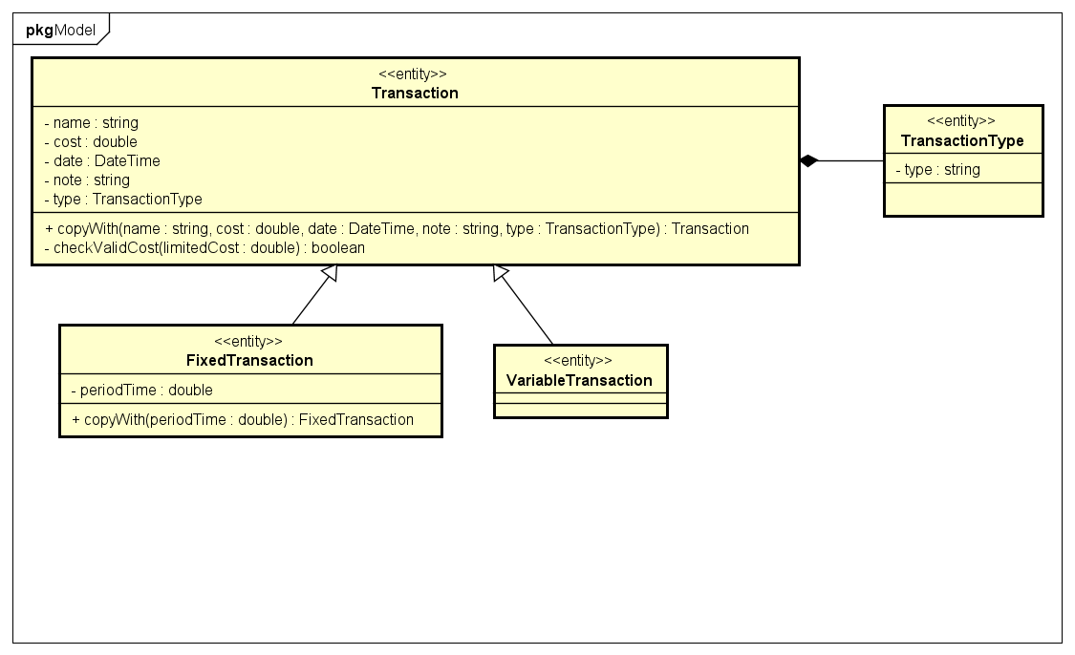

### Attribute

|  |  |  |  |
| --- | --- | --- | --- |
| # | Tên | Kiểu trả về | Description |
| 1 | name | string | transaction’s name |
| 2 | date | DateTime | transaction’date |
| 3 | cost | double | transaction’ cost |
| 4 | note | string | note |
| 5 | transactionType | TransactionType | EXPENSE/TURNOVER |

### Operation

|  |  |  |  |
| --- | --- | --- | --- |
| *#* | *Tên* | *Kiểu dữ liệu trả về* | *Mô tả (Mục đích)* |
| 1 | copyWith | Transaction | create a copy transaction when updating information of transaction |
| 2 | checkValidCost | boolean | the cost must be smaller than the limited cost |

### Parameter

* limitedCost: the limited cost for a transaction every day

### Exception

* Invalid cost: when the cost is bigger than the limited cost

### Method

* No

### State

* No

## CustomTransaction entity

### Class Diagram

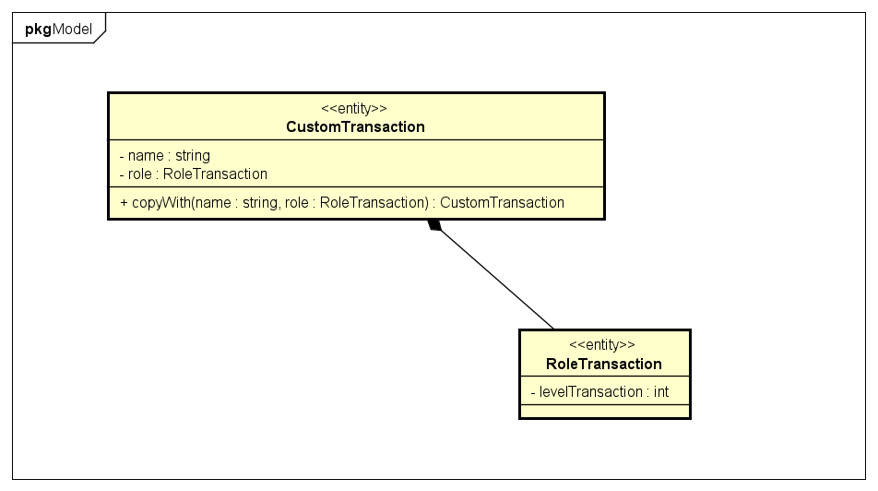

### Attribute

|  |  |  |  |
| --- | --- | --- | --- |
| # | Tên | Kiểu trả về | Description |
| 1 | name | string | custom transaction’name |
| 2 | roleTransaction | RoleTransaction | role of Transaction |

### Operation

|  |  |  |  |
| --- | --- | --- | --- |
| *#* | *Tên* | *Kiểu dữ liệu trả về* | *Mô tả (Mục đích)* |
| 1 | copyWith | CustomTransaction | create a copy CustomTransaction when updating information of CustomTransaction |

### Parameter

* Name: new name of custom transaction
* Role: new role of role transaction

### Exception

* No

### Method

* No

### State

* No

## CustomTransaction entity

### Class Diagram

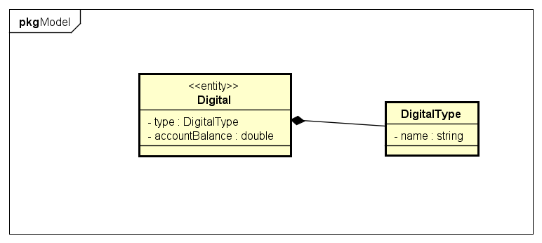

### Attribute

|  |  |  |  |
| --- | --- | --- | --- |
| # | Tên | Kiểu trả về | Description |
| 1 | type | string | type of digital |
| 2 | account balance | double | account balance of user |

### Operation

* No

### Parameter

* No

### Exception

* No

### Method

* No

### State

* No

# Controller Class